Translate the roman numerals to numbers and we derive this table:

|  |  |  |  |  |  |  |  |
| --- | --- | --- | --- | --- | --- | --- | --- |
| 7 | 58 | 59 | 56 | 14 | 62 | 5 | 41 |
| 49 | 50 | 48 | 30 | 53 | 55 | 54 | 20 |
| 64 | 42 | 16 | 44 | 45 | 35 | 47 | 51 |
| 33 | 23 | 46 | 9 | 37 | 11 | 39 | 40 |
| 25 | 26 | 27 | 28 | 32 | 52 | 31 | 29 |
| 15 | 18 | 19 | 12 | 34 | 22 | 8 | 24 |
| 36 | 1 | 38 | 60 | 13 | 61 | 17 | 43 |
| 2 | 10 | 3 | 4 | 63 | 6 | 57 | 21 |

Decode the image using the semaphore flag signals and we get “**SOLVING THE IMAGE WOULD GRANT THE USER INFO TO DECODE NEXT HINT**”

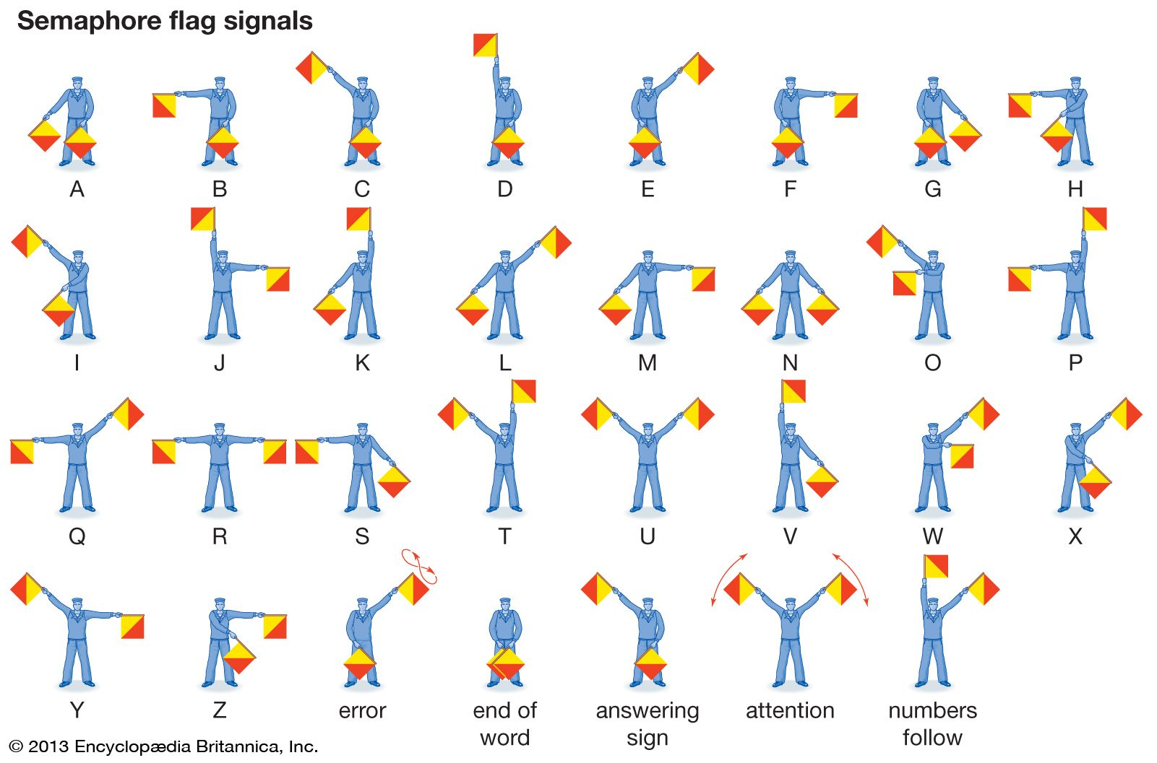

Chess board layout is also 8x8

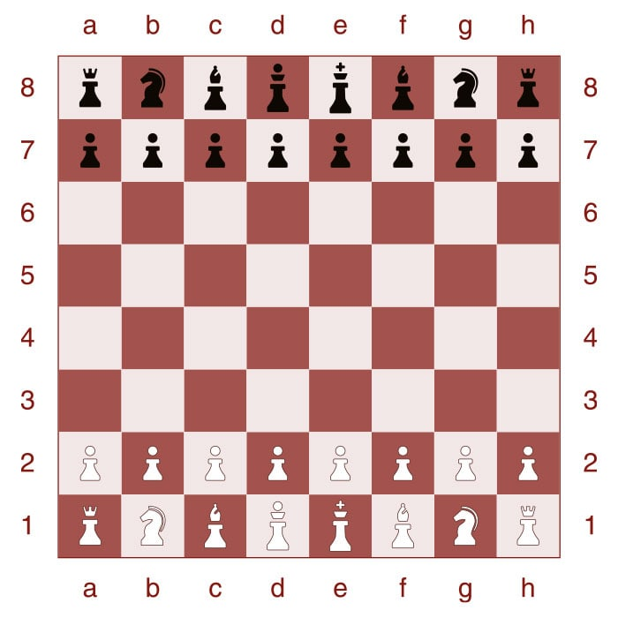

Chess Steganography?